# Section 1.4: Inverse Functions

An inverse function reverses the operation done by a particular function. In other words, whatever a function does, the inverse function undoes it. In this section, we define an inverse function formally and state the necessary conditions for an inverse function to exist. We examine how to find an inverse function and study the relationship between the graph of a function and the graph of its inverse. Then we apply these ideas to define and discuss properties of the inverse trigonometric functions.

## Existence of an Inverse Function

Given a function $f$ with domain $D$ and range $R$, its **inverse function** (if it exists) is the function $f^{-1}$ with domain $R$ and range $D$ such that $f^{-1}\left(y\right)=x$ if $f\left(x\right)=y$. In other words, for a function $f$ and its inverse $f^{-1}$,

$f^{-1}\left(f(x)\right)=x$ for all $x$ in $D$, and $f\left(f^{-1}(y)\right)=y$ for all $y$ in $R$.

Note that $f^{-1}$ is read as “f inverse” (the -1 is not used as an exponent).

Recall that a function has exactly one output for each input. Therefore, to define an inverse function, we need to map each input to exactly one output. A function that sends each input to a different ouput is called a one-to-one function.

We say a $f$ is a **one-to-one function** if $f\left(x_{1}\right)≠f\left(x_{2}\right)$ when $x_{1}≠x_{2}$.

One way to determine whether a function is one-to-one is by looking at its graph. If a function is one-to-one, then no two inputs can be send to the same output.

A function $f$ is one-to-one if and only if every horizontal line intersects the graph of $f$ no more than once.

Examples

1. Given $f\left(x\right)=5x-7$ and $g\left(x\right)=\frac{x+5}{7}$, use composition to determine which pairs of functions are inverses.
2. For each of the following functions, use the horizontal line test to determine whether it is one-to-one.
   1. 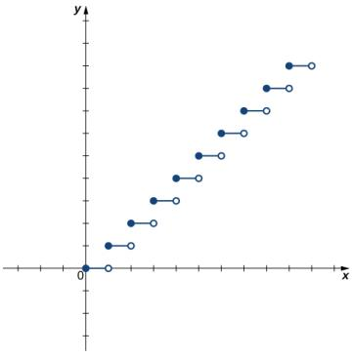
   2. 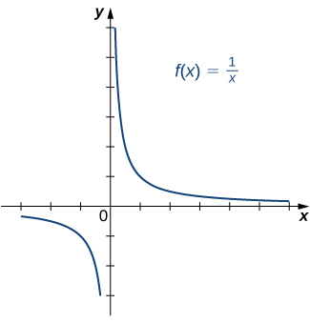

## Finding a Function’s Inverse

We can now consider one-to-one functions and show how to find their inverses.

**Finding an Inverse Function**

1. Solve the equation $y=f(x)$ for $x$.
2. Interchange the variables $x$ and $y$ and write $y=f^{-1}(x)$.

Example: Find the inverse for the function $f\left(x\right)=3x-4$. State the domain and range of the inverse function. Verify that $f^{-1}\left(f(x)\right)=x$.

### Graphing Inverse Functions

Consider the graph of $f$ shown in the figure below and a point $\left(a,b\right)$ on the graph. Since $b=f(a)$, then $f^{-1}\left(b\right)=a$. Therefore, when we graph $f^{-1}$, the point $(b,a)$ is on the graph. As a result, the graph of $f^{-1}$ is a reflection of the graph of $f$ about the line $y=x$.

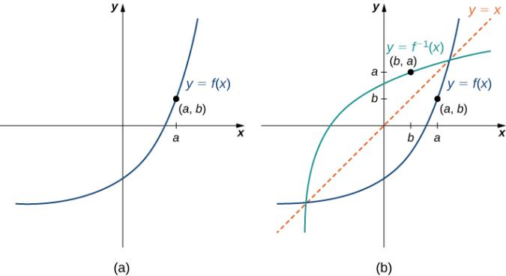

Example: For the graph of $f$ in the following image, sketch a graph of $f^{-1}$ by sketching the line $y=x$ and using symmetry. Identify the domain and range of $f^{-1}$.

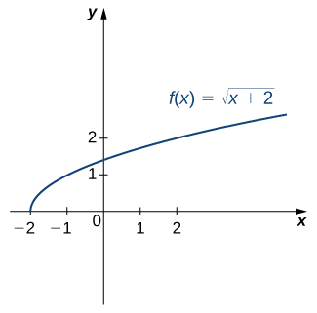

### Restricting Domains

Not all functions are one-to-one. However, we can choose a subset of the domain of $f$ such that the function is one-to-one. This subset is called a restricted domain. By restricting the domain of $f$, we can define a new function $g$ such that the domain of $g$ is the restricted domain of $f$ and $g\left(x\right)=f(x)$ for all $x$ in the domain of $g$. Then we can define an inverse function for $g$ on that domain.

Example: Consider the function $f\left(x\right)={\left(x+1\right)}^{2}$. Sketch the graph of $f$ and sue the horizontal line test to show that $f$ is not one-to-one. Then, show that $f$ is one-to-one on the restricted domain $[-1, ∞)$. Determine the domain and range for the inverse of $f$ on this restricted domain and find a formula for $f^{-1}$.

## Inverse Trigonometric Functions

The six basic trigonometric functions are periodic, and therefore they are not one-to-one. However, if we restrict the domain of a trigonometric function to an interval where it is one-to-one, we can define its inverse. We can restrict the domains of the trigonometric functions to define **inverse trigonometric functions**, which are functions that tell us which angle in a certain interval has a specified trigonometric value.

The inverse sine function, denoted $\sin^{-1}$ or arcsin, and the inverse cosine function, denoted $\cos^{-1}$ or arccos, are defined on the domain $D=\left\{x|-1≤x≤1\right\}$ as follows:

$\sin^{-1}\left(x\right)=y$ if and only if $\sin\left(y\right)=x$ and $-\frac{π}{2}≤y≤\frac{π}{2}$;

$\cos^{-1}\left(x\right)=y$ if and only if $\cos\left(y\right)=x$ and $0≤y≤π$.

The inverse tangent function, denoted $\tan^{-1}$ or arctan, and the inverse cotangent function, denoted $\cot^{-1}$ or arccot, are defined on the domain $D=\left\{x|-∞<x<∞\right\}$ as follows:

$\tan^{-1}\left(x\right)=y$ if and only if $\tan\left(y\right)=x$ and $-\frac{π}{2}<y<\frac{π}{2}$;

$\cot^{-1}\left(x\right)=y$ if and only if $\cot\left(y\right)=x$ and $0<y<π$.

The inverse cosecant function, denoted $\csc^{-1}$ or arccsc, and the inverse secant function, denoted $\sec^{-1}$ or arcsec, are defined on the domain $D=\left\{x|\left|x\right|≥1\right\}$ as follows:

$\csc^{-1}\left(x\right)=y$ if and only if $\csc\left(y\right)=x$ and $-\frac{π}{2}≤y≤\frac{π}{2}$, $y≠0$;

$\sec^{-1}\left(x\right)=y$ if and only if $\sec\left(y\right)=x$ and $0≤y≤π$, $y≠\frac{π}{2}$.

Examples: Evaluate each of the following expressions:

$\sin^{-1}\left(-\frac{\sqrt{3}}{2}\right)$

$tan\left(\tan^{-1}\left(-\frac{1}{\sqrt{3}}\right)\right)$

$\cos^{-1}\left(cos\left(\frac{5π}{4}\right)\right)$

$\sin^{-1}\left(cos\left(\frac{2π}{3}\right)\right)$